Section B:

**Cells schematic, layout and checks**

4bit-XOR:

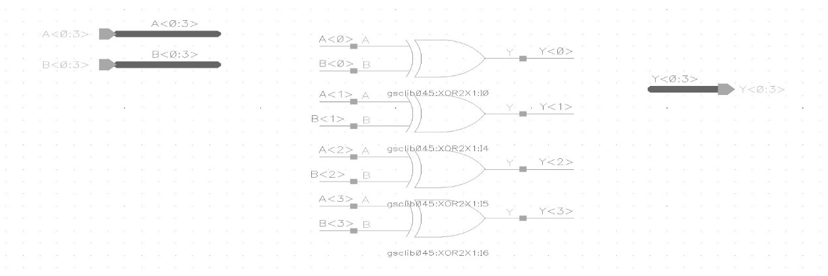

Size=(1.9)*(7.8)=14.82

Checks:

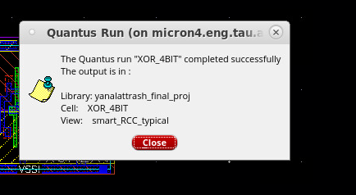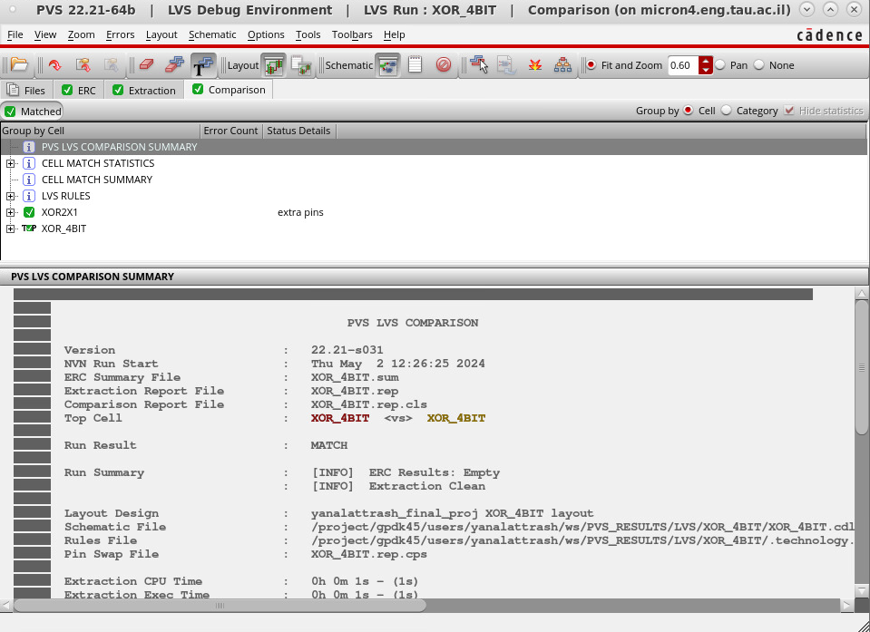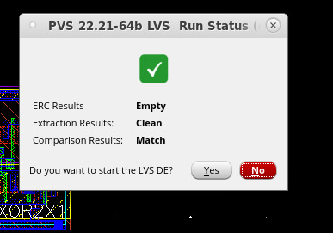

MUX4-1- 4BITS

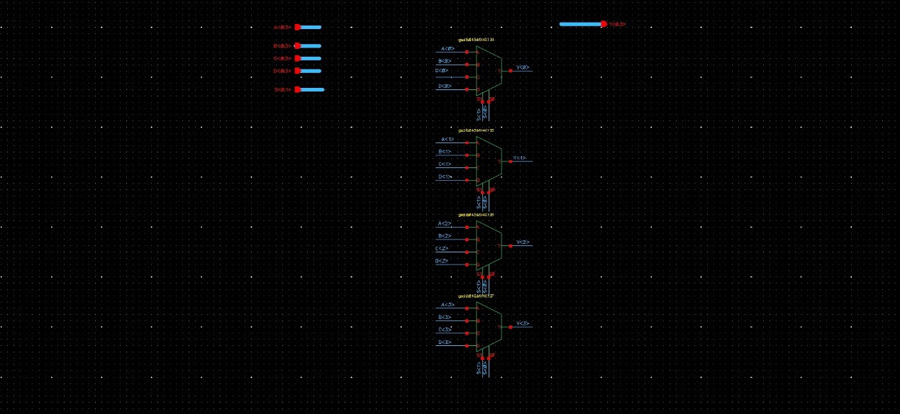

Size=(9.49)*(3.66)=34.737

Checks:

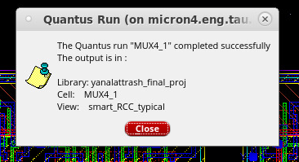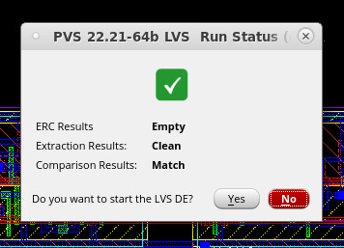

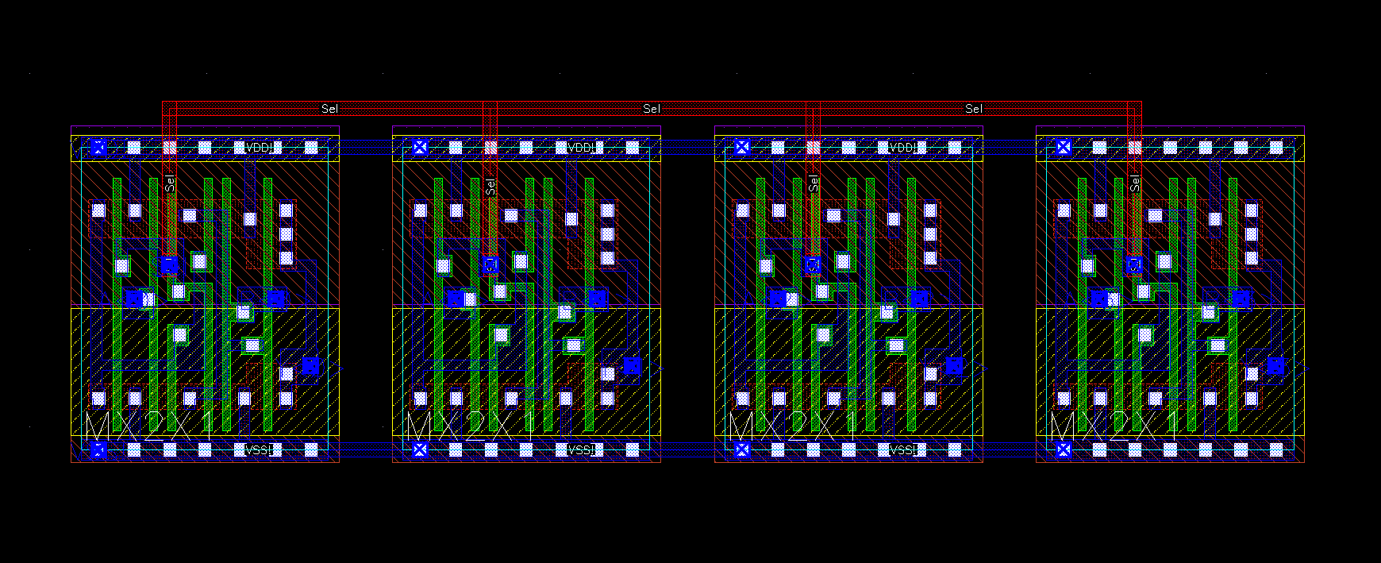

Size=(6.985)*(2.04)=14.2494

Checks:

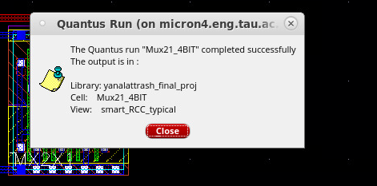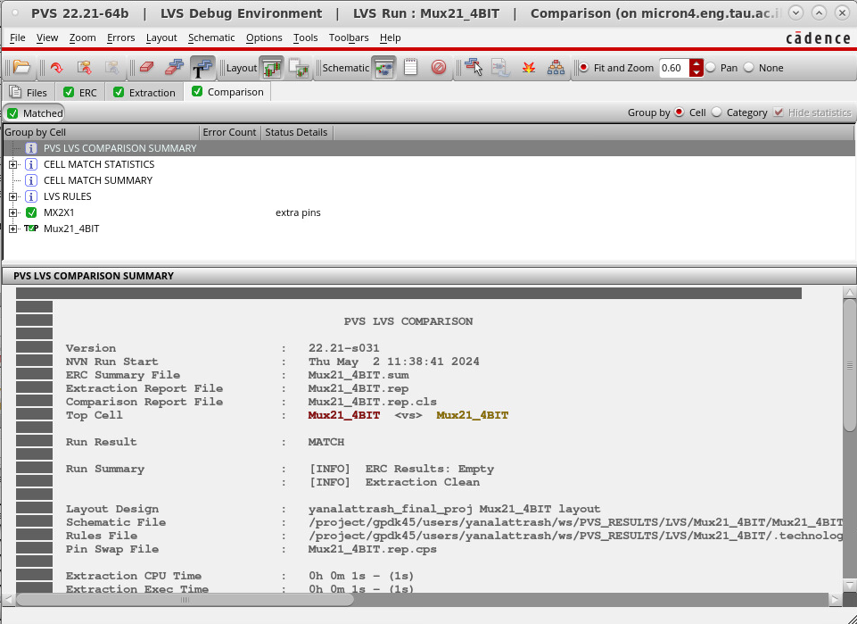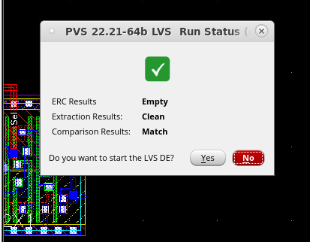

+ Demux1:2 Demux1:24bit

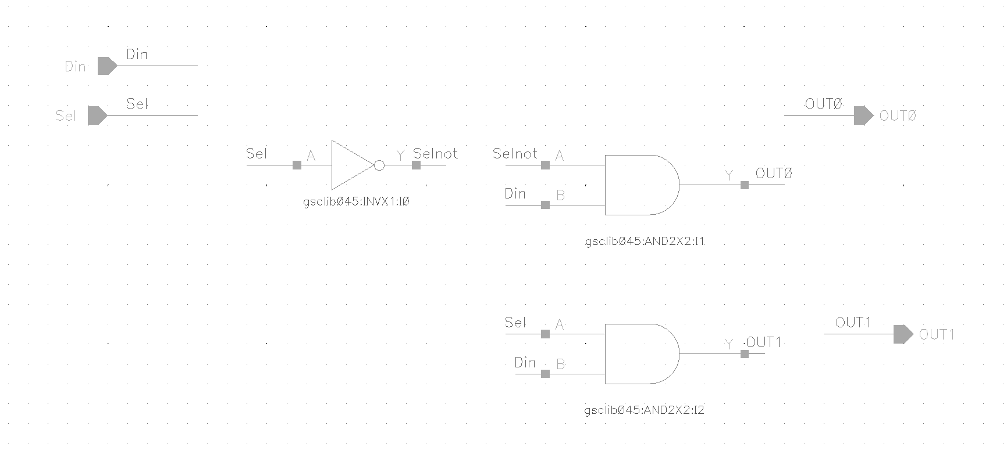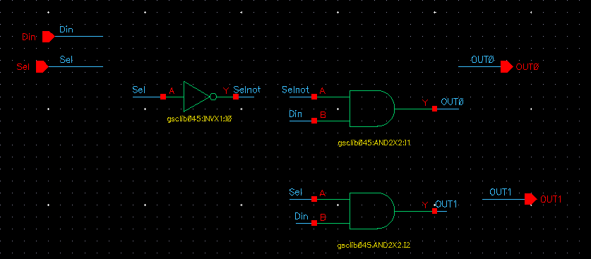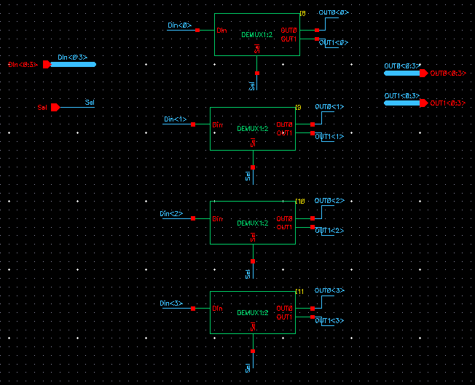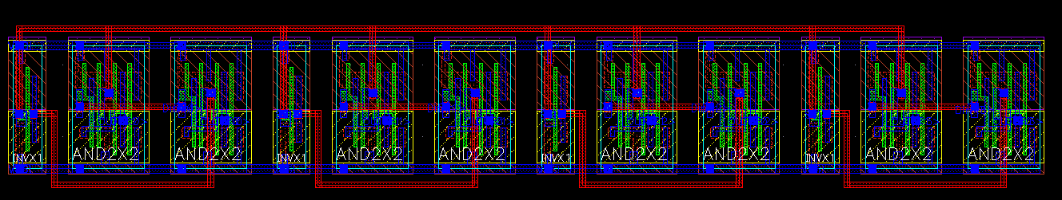

Demux1:2-4bit Size=(14.37)*(2.25)=32.3325

Demux1:2 Size =(3.365)*(2.25)=7.57125

Check:

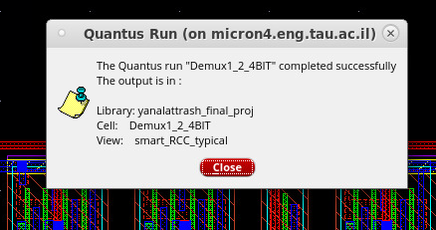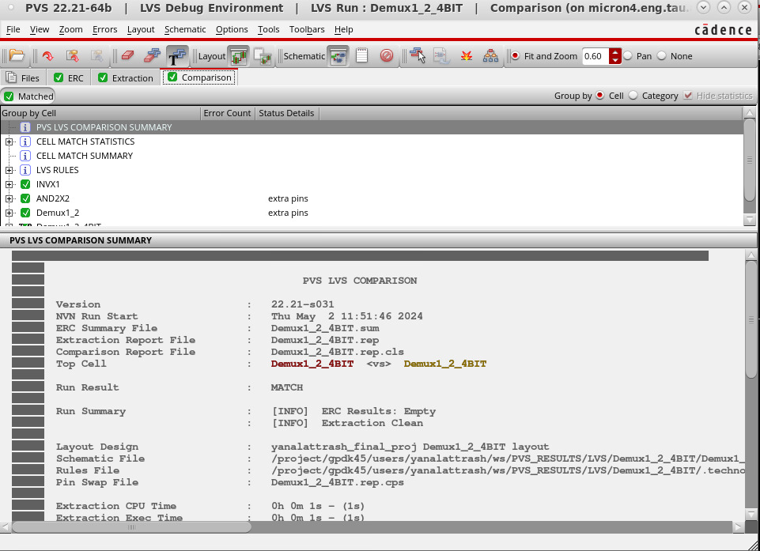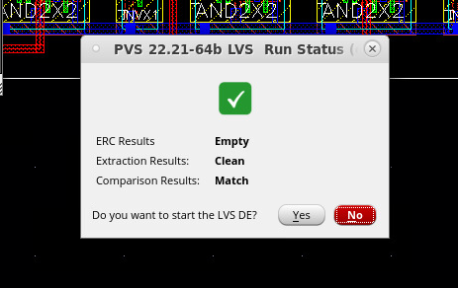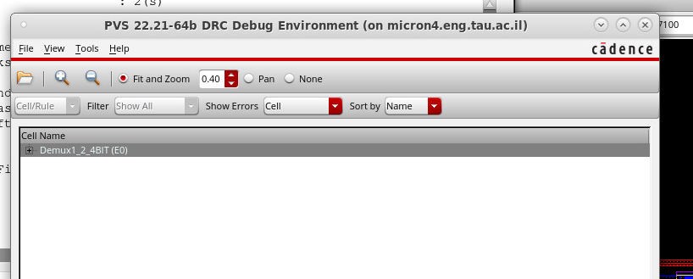

BSR

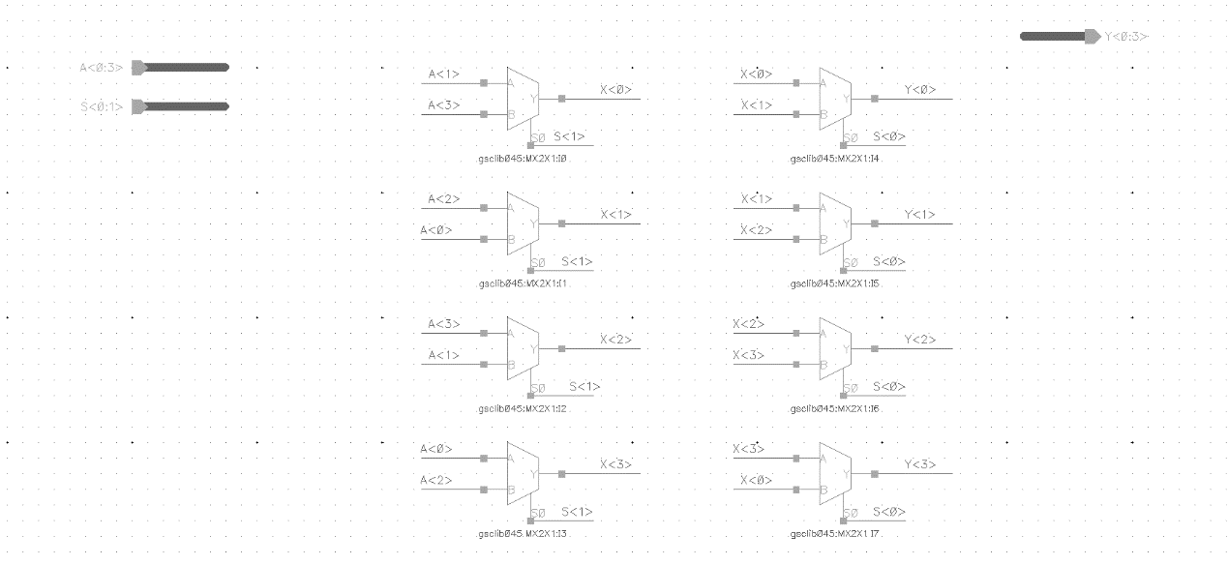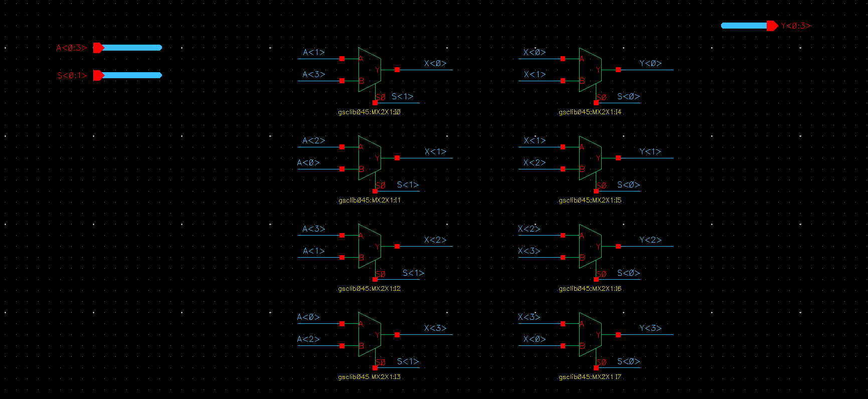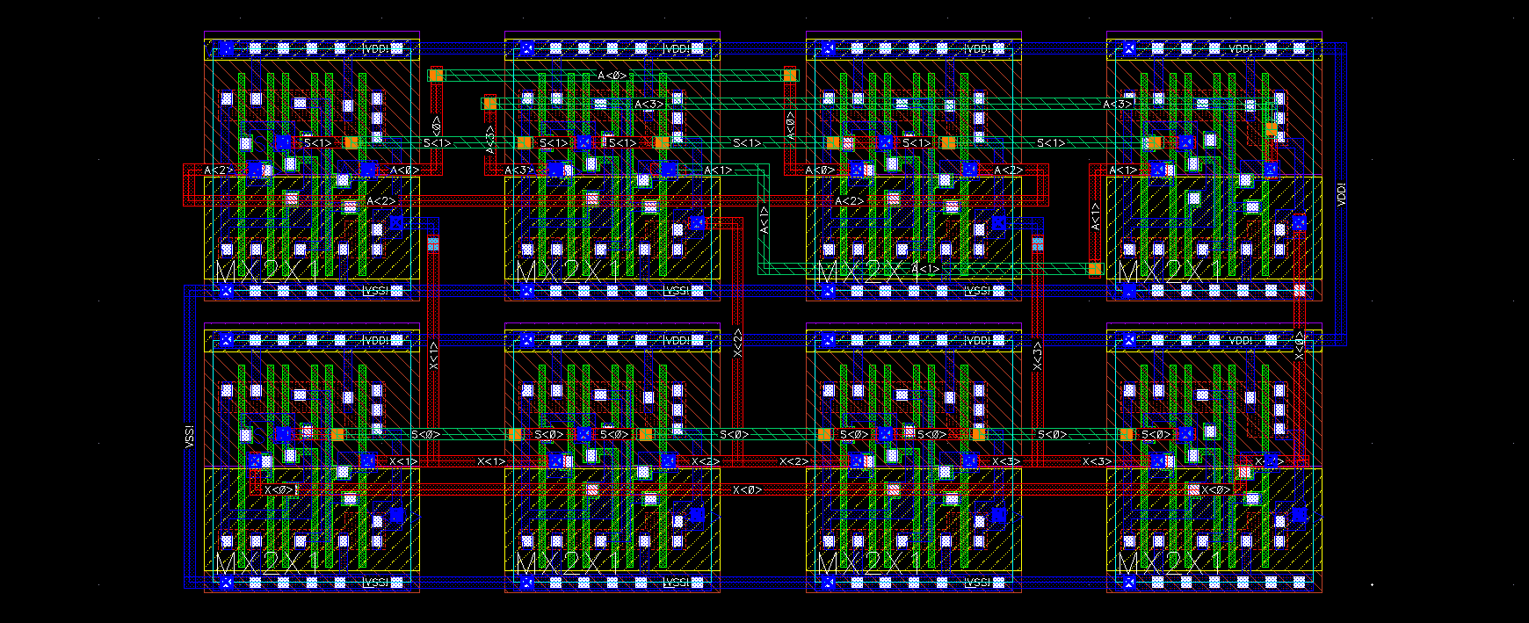

Size=(8.37)*(4.225)=35.6144

Checks:

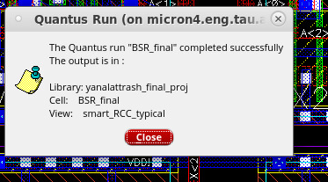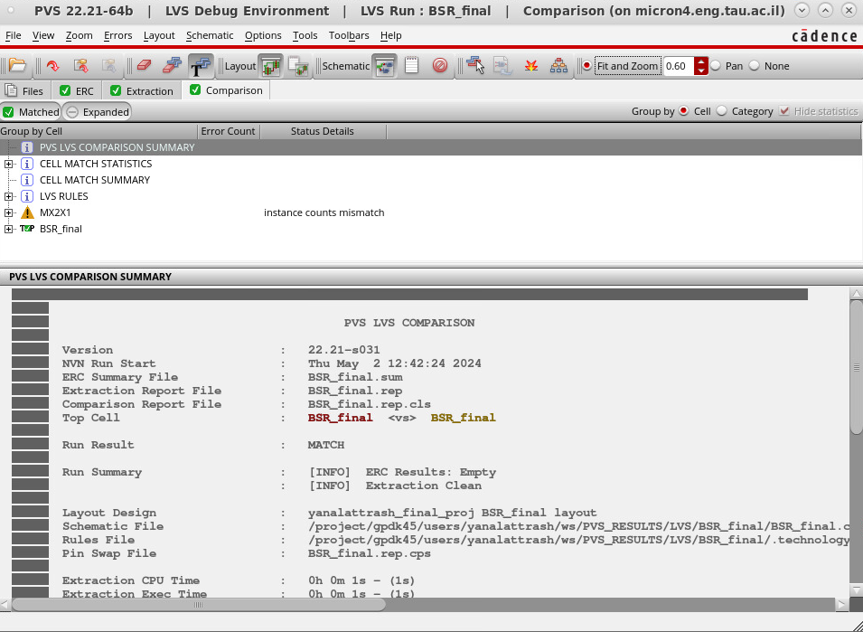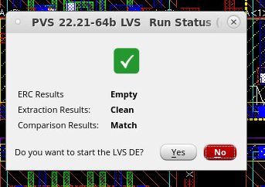

And_4bit

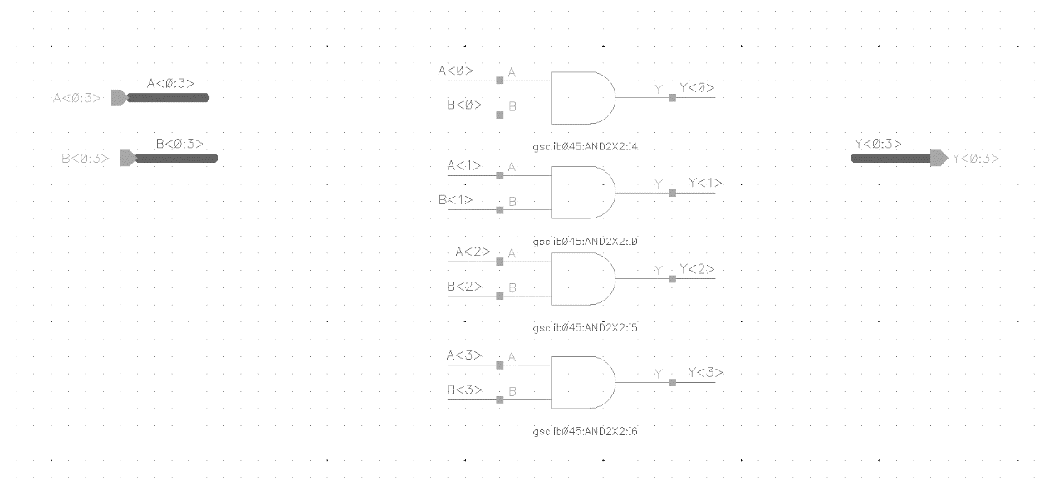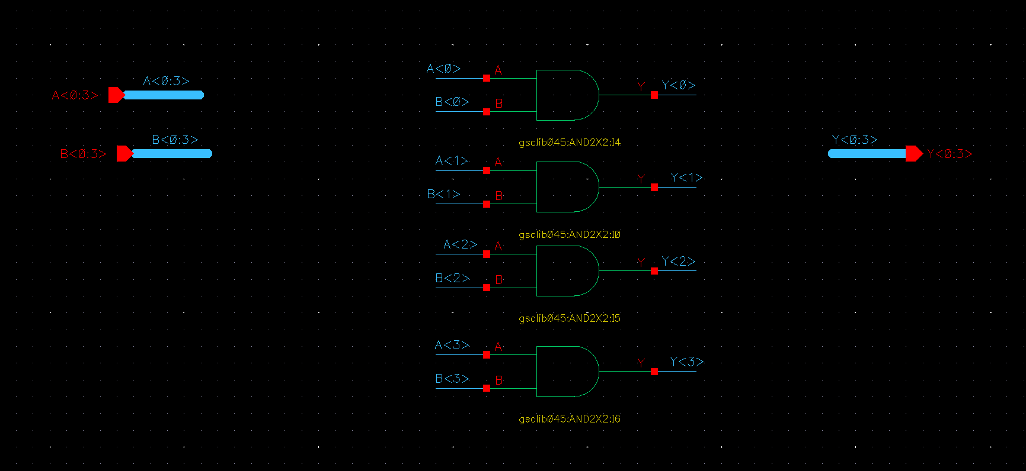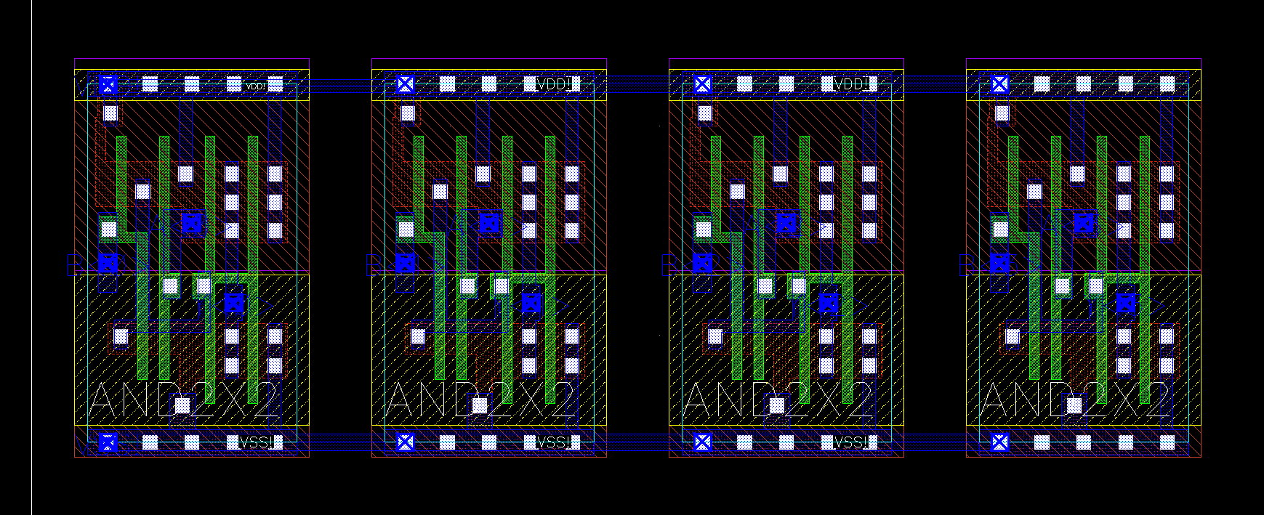

Size =(1.9)*(5.38) =10.222

Checks:

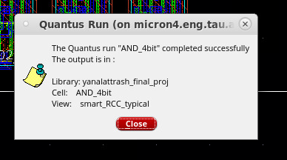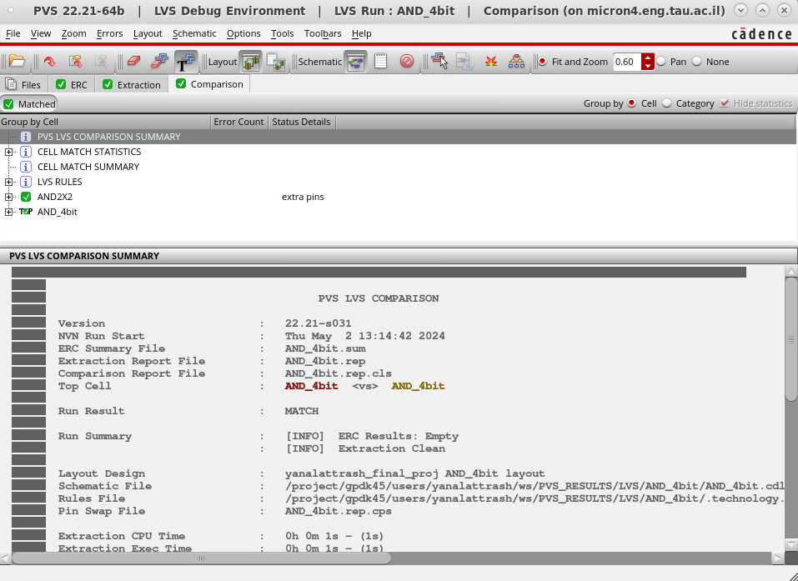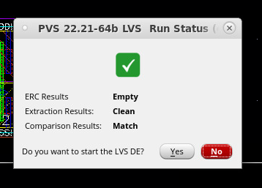

5bit-reg

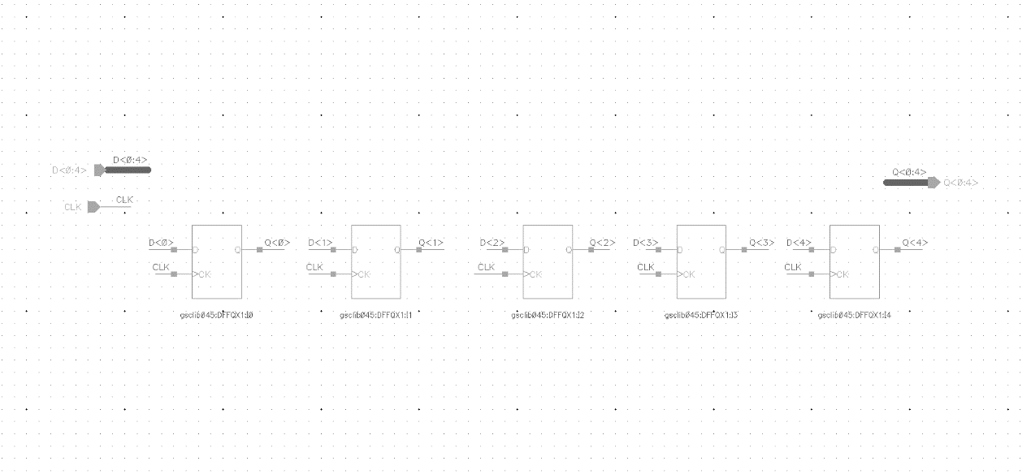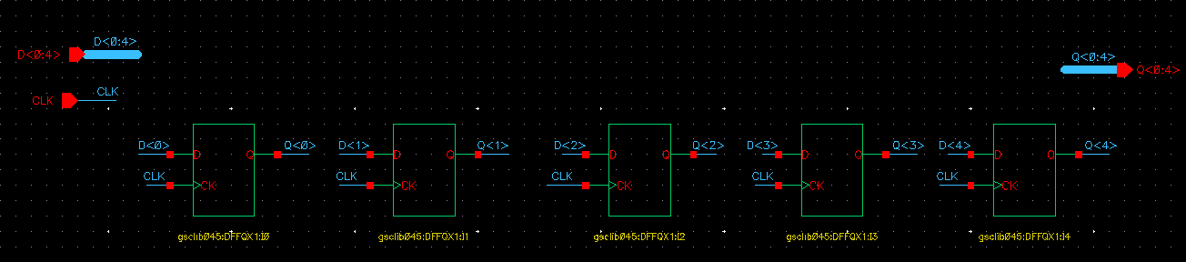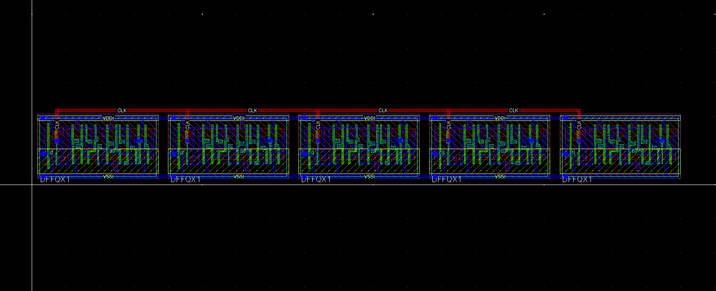

Size =(2.155)*(18.805) = 40.53

Checks:

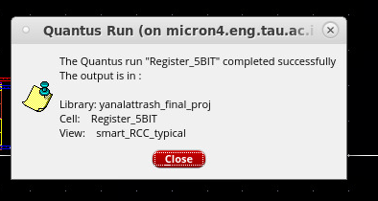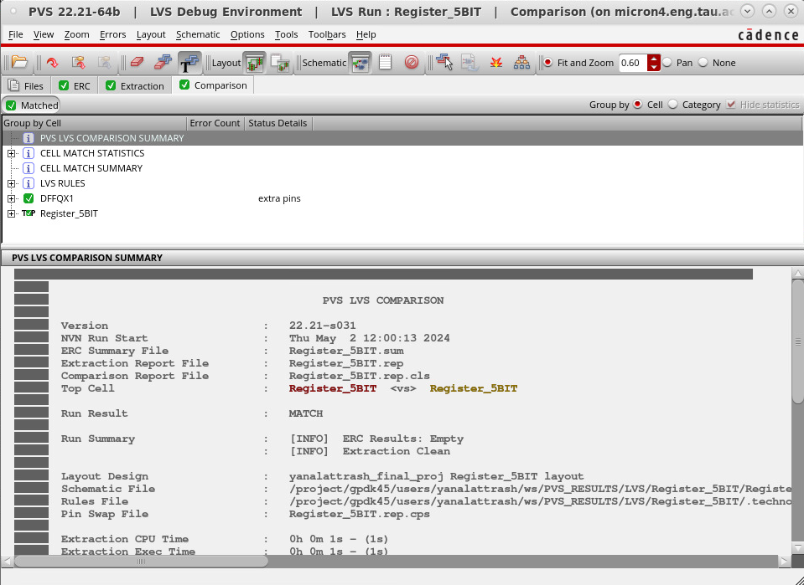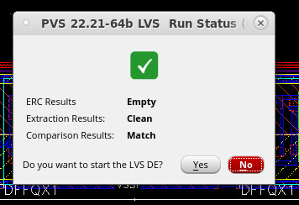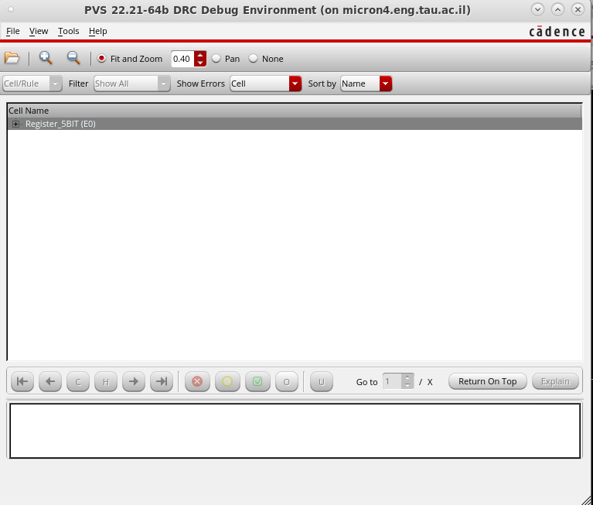

4-bit reg

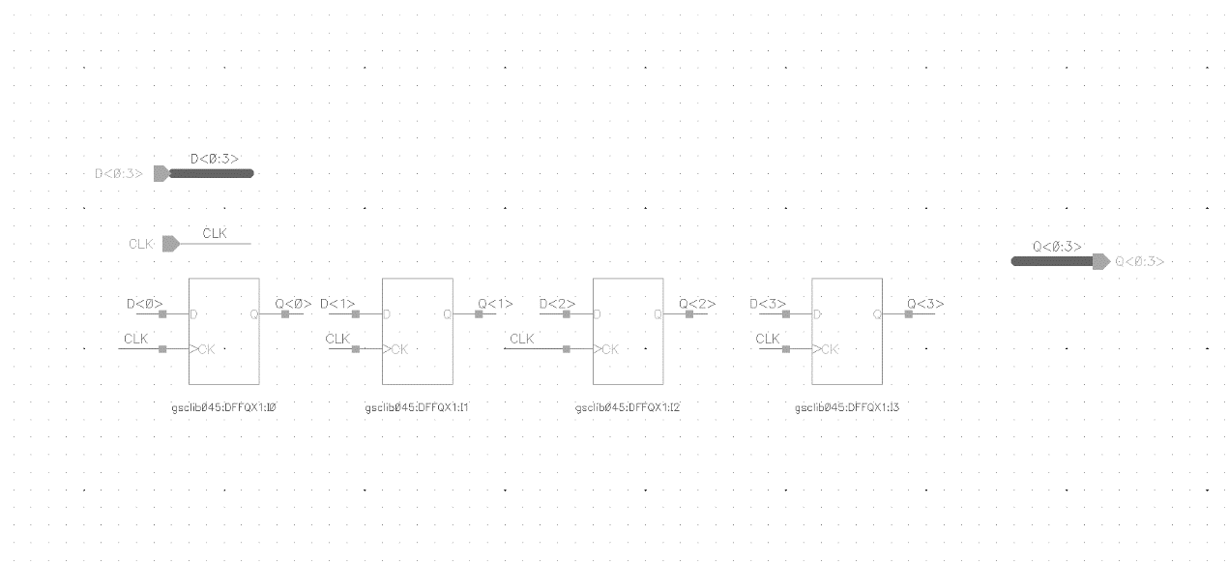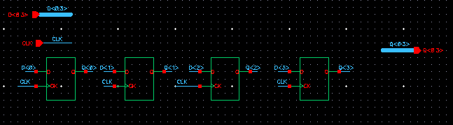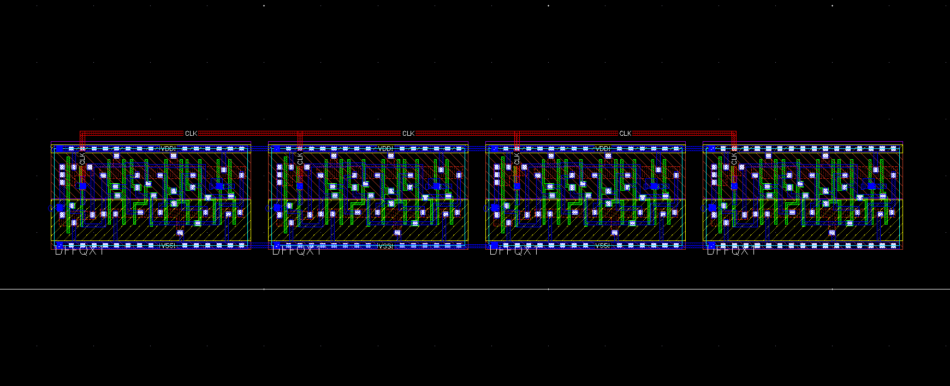

Size= (1.9) *(14.98) = 28.462

Checks:

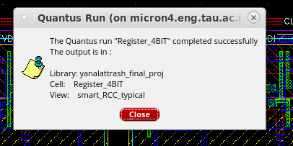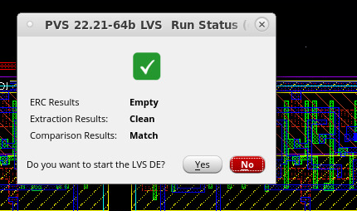

King stone Adder Schematic:

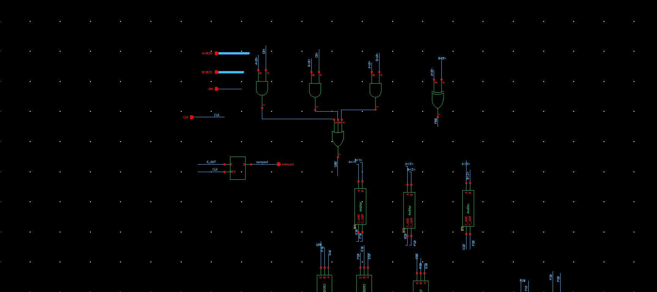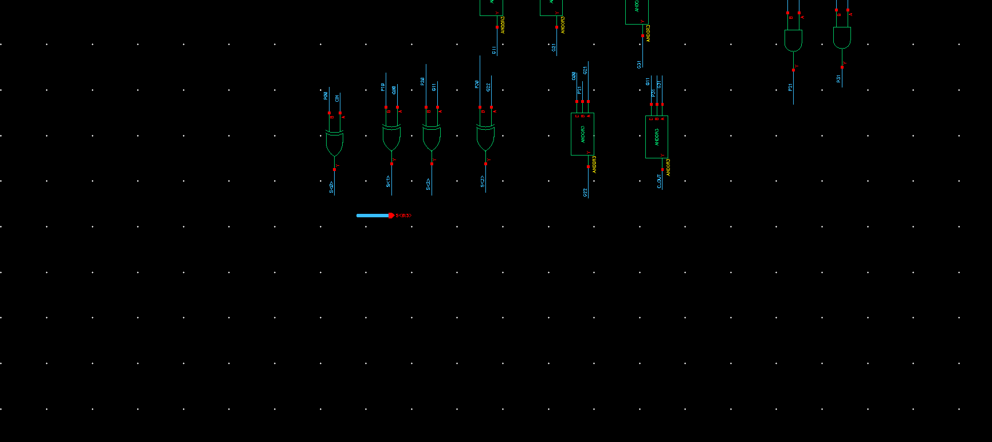

Add_Xor block Schematic:

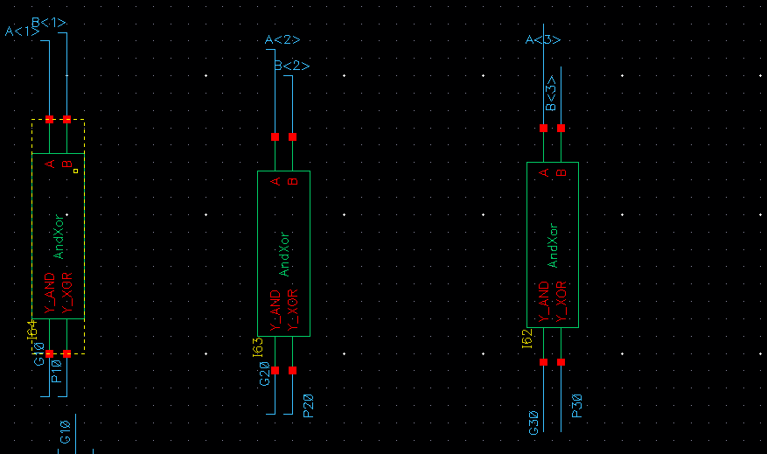

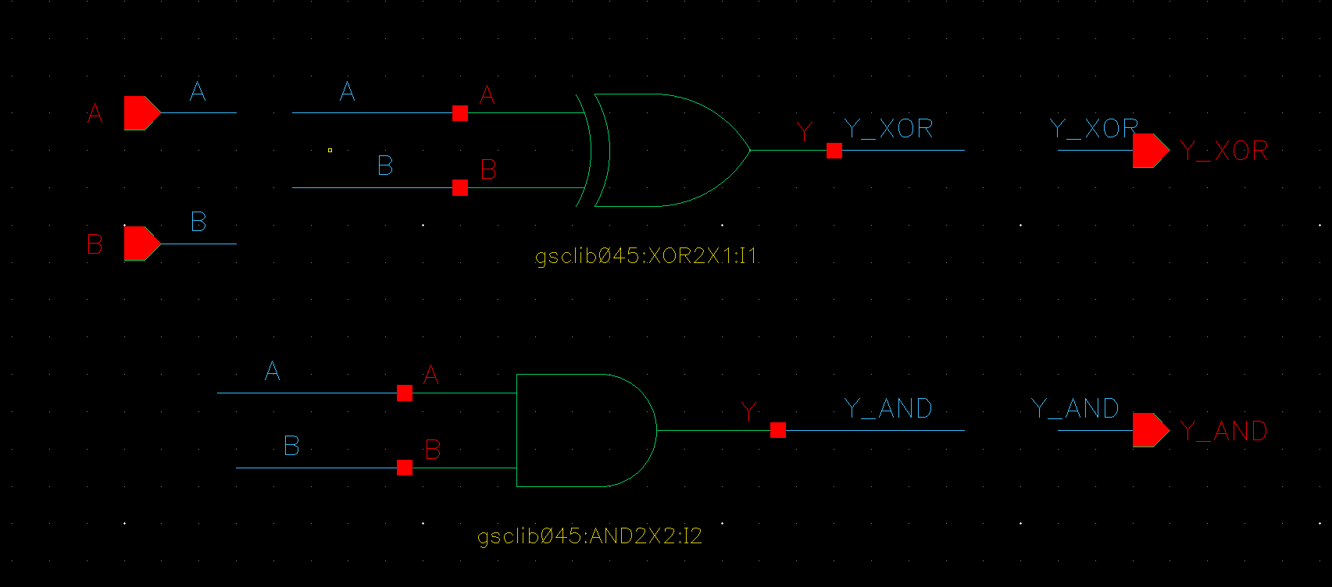

Andor3 gate Schematic:

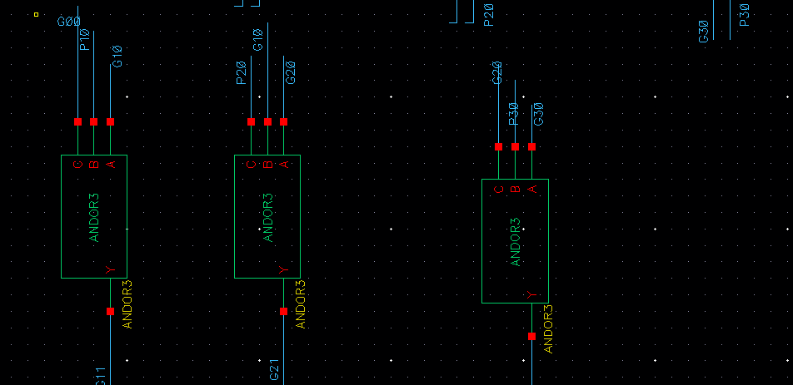

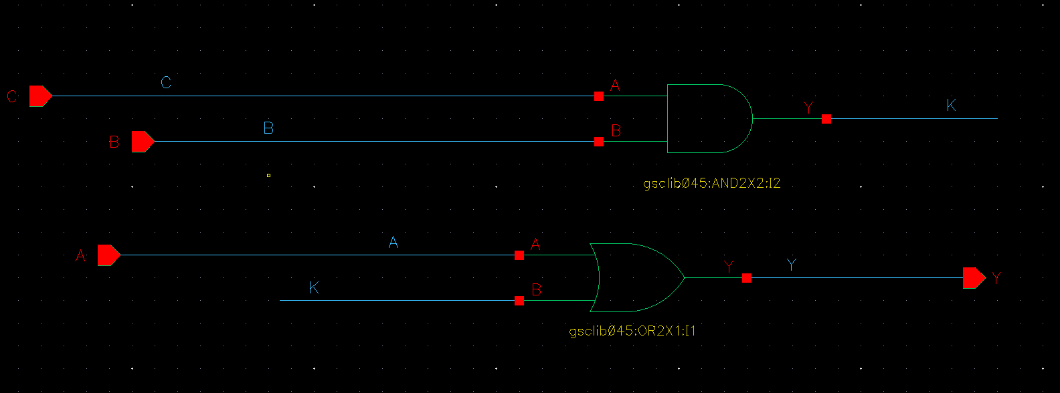

Kogge Stone adder layout :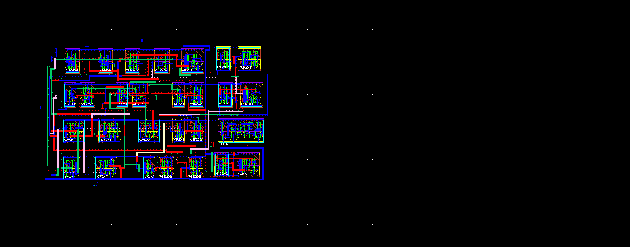Size=(10.315)*(17.12)=176.6

Check: 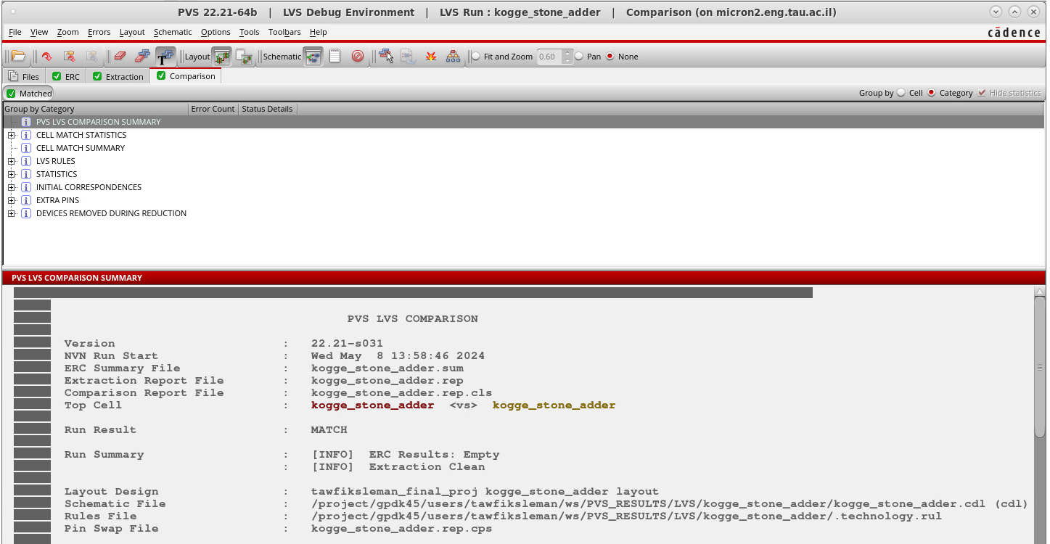

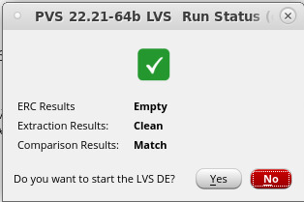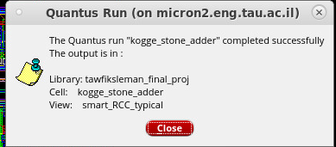

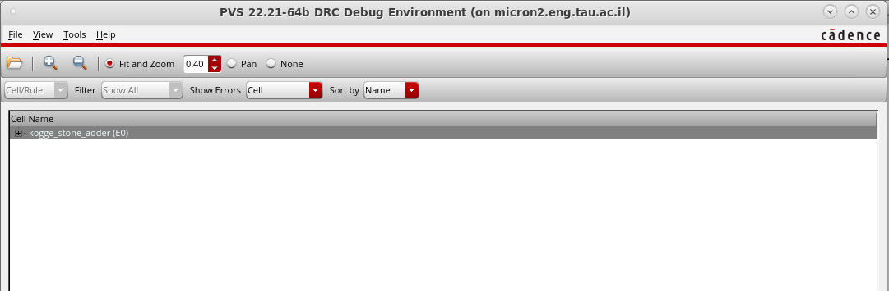Adder-sub block schematic:

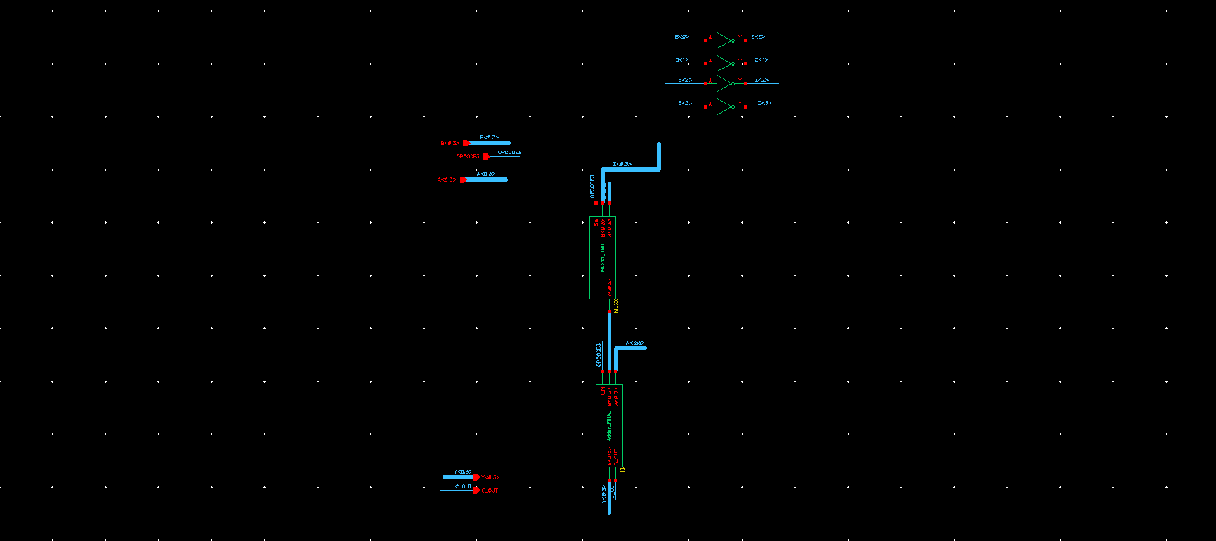

Adder-sub block layout:

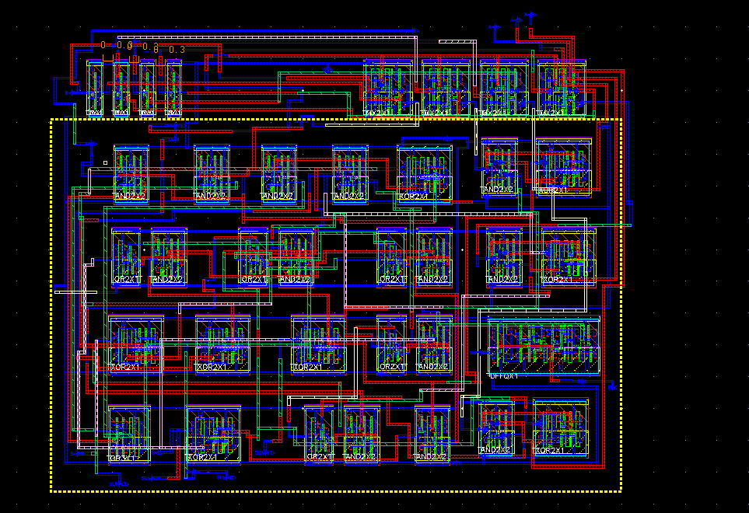

Size = (18.31)*(15.04) =275.4

Check: 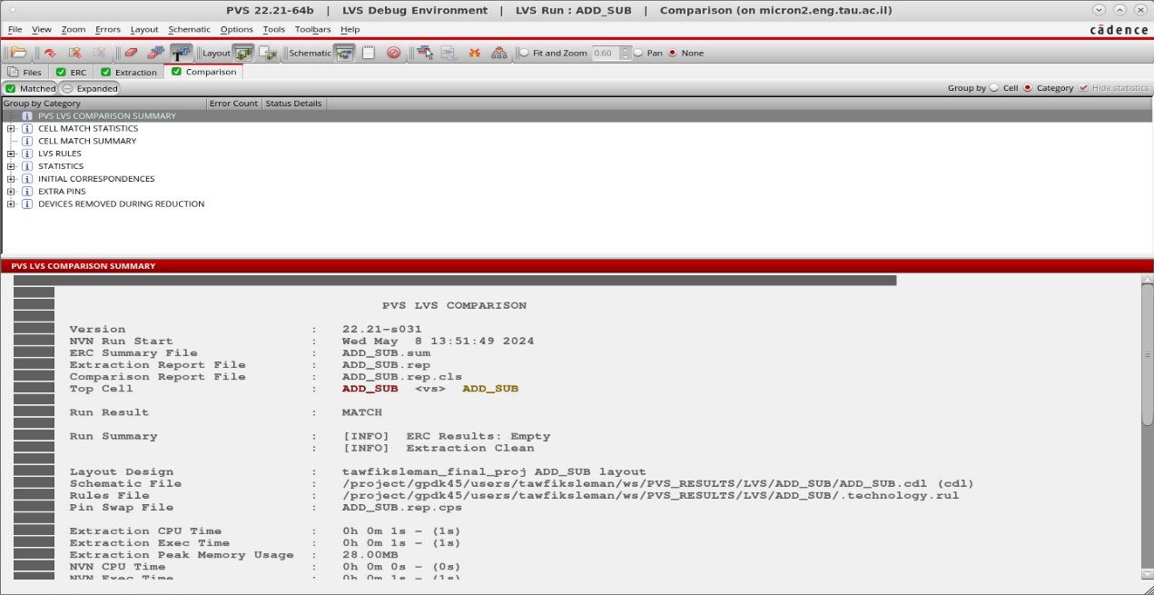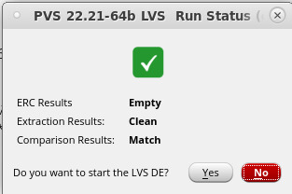

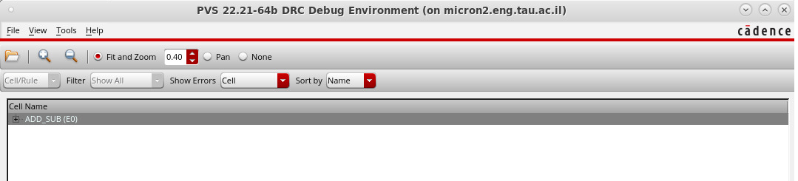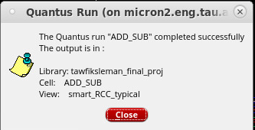

ALU Schematic:

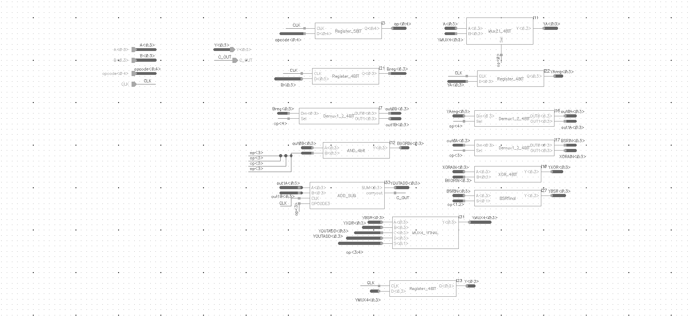

ALU Floorplan:

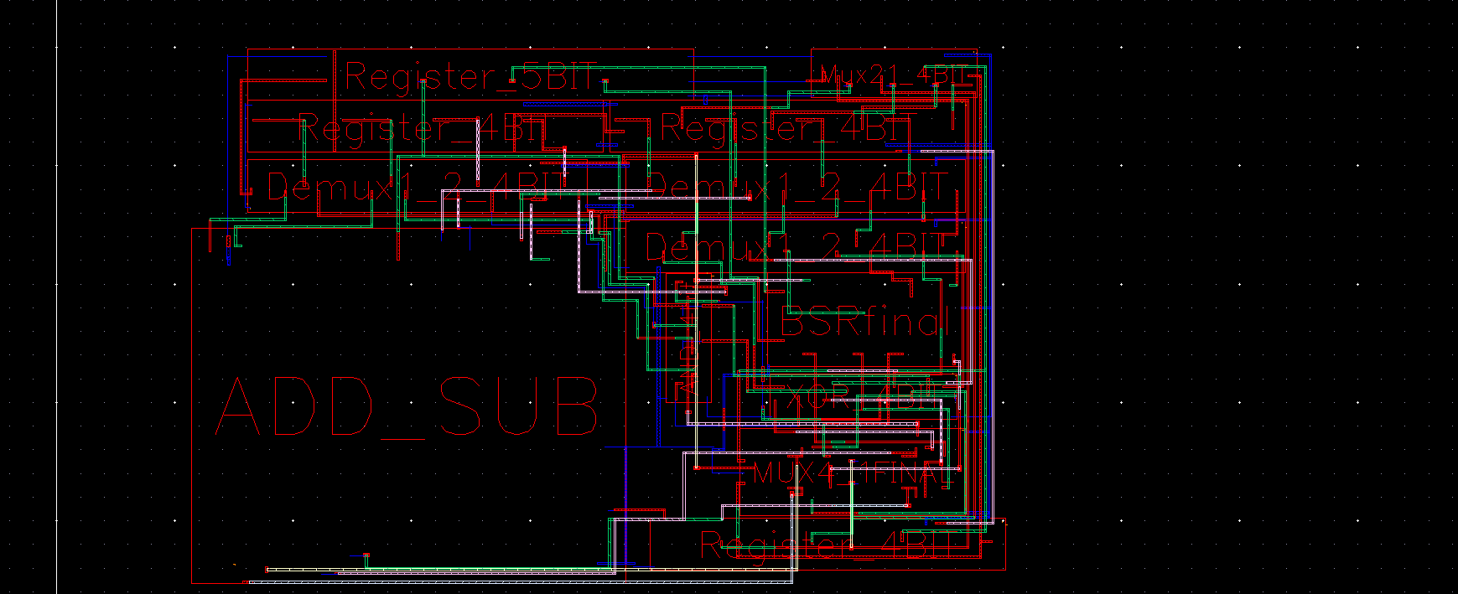

ALU layout:

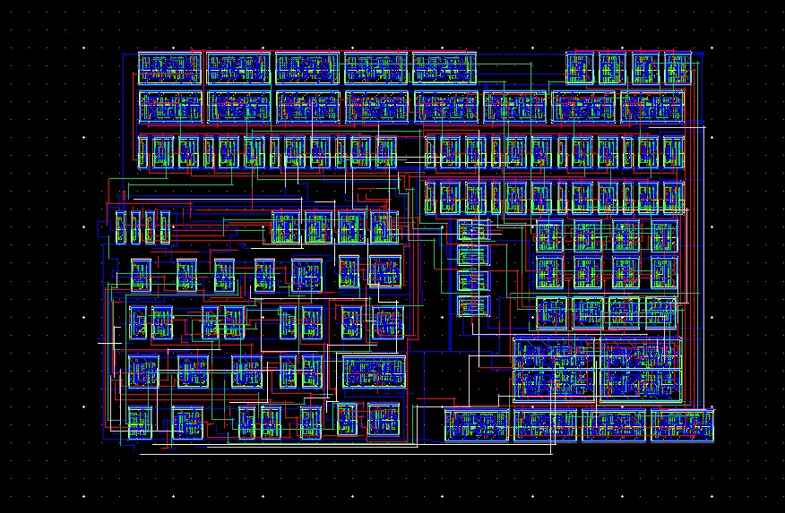

Size= (33.555)*(22.56) =757

ALU check:

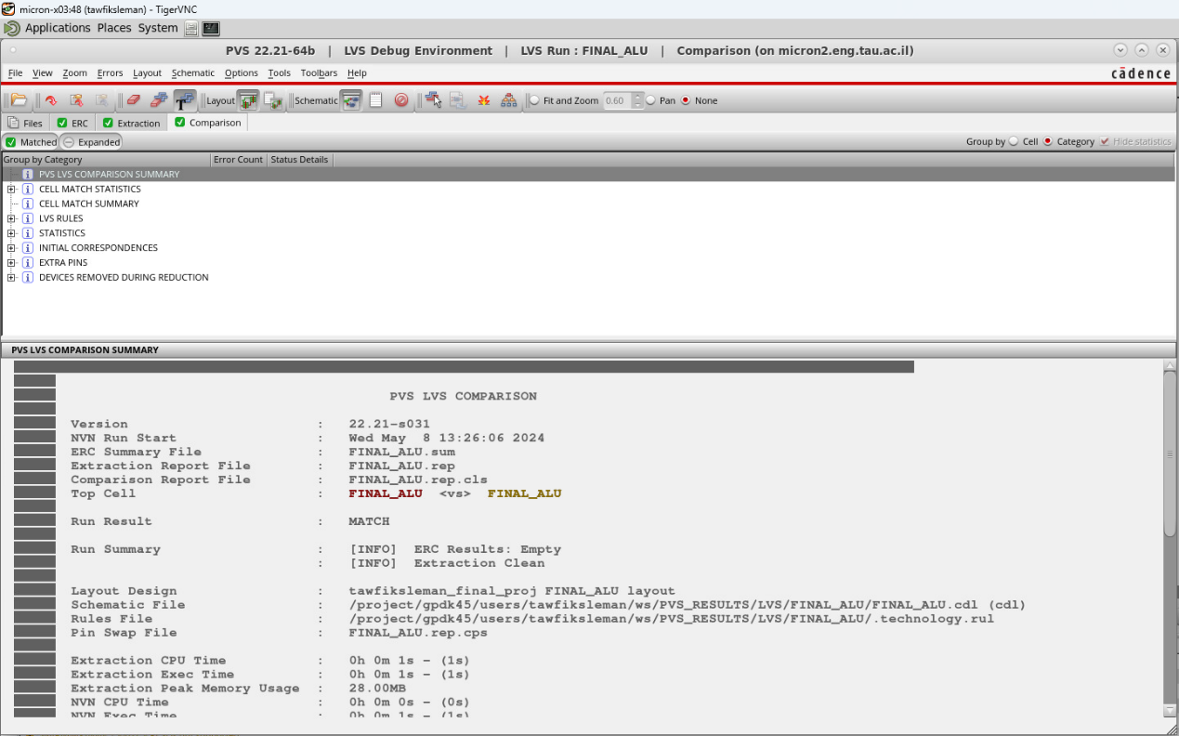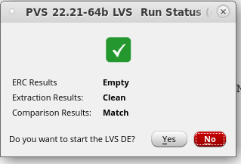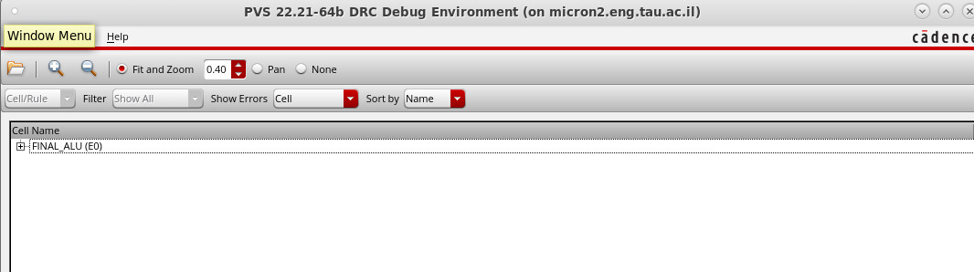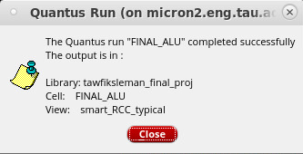

Total cells size:

|  |  |
| --- | --- |
| cell size µm2 | cell |
| 40.53 | 5-bits register |
| 28.462 | 4-bits registerB |
| 32.3325 | Demux 1:2 (4bits) |
| 10.22 | And (4bits) |
| 34.74 | MUX 2:1(4bits) |
| 28.462 | 4 bit A reg |
| 32.3325 | Demux 1:2(4bits) |
| 32.3325 | Demux 1:2(4bits) |
| 14.82 | xor |
| 275.4 | Add-sub |
| 34.74 | MUX 4:1(4bits) |
| 35.614 | BSR |
| 28.462 | 4 bit Y reg |
| 628.46 | TOTAL SIZE |

we required that visualization area less than 1.5 of the cells total size. 1.5 of Total cells size = 1.5*628.46=942.7, we see that its grater that ALU size which is 757.

**ALU Simulations:**

**Adder test:**

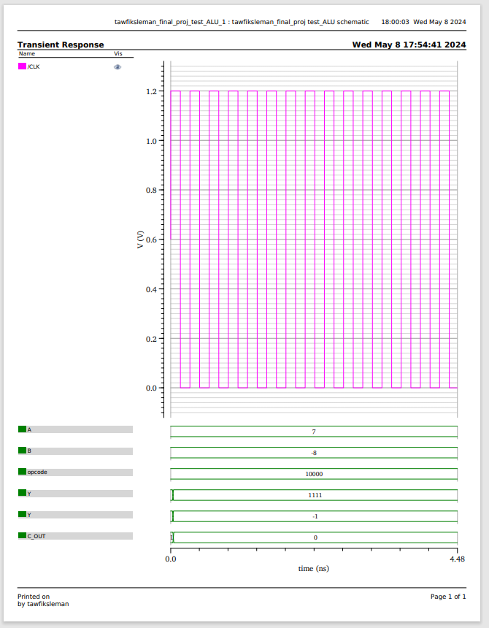

In the graph, we see that A=0111 in 2's complement (equivalent to 7 in decimal) and b=1000 in 2's complement (equivalent to -8 in decimal) was inputted into the ALU with opcode 10000, representing the "add" command. The resulting output is 1111, which translates to -1 in decimal. Upon adding 7 and -8, we observe a carry-out (cout) of 0, indicating the absence of overflow.

NOTICE that in this case we don’t have an overflow because XOR (CarryIN-4bit, Carryout-4bit)≠1

**Adding with feedback test:**

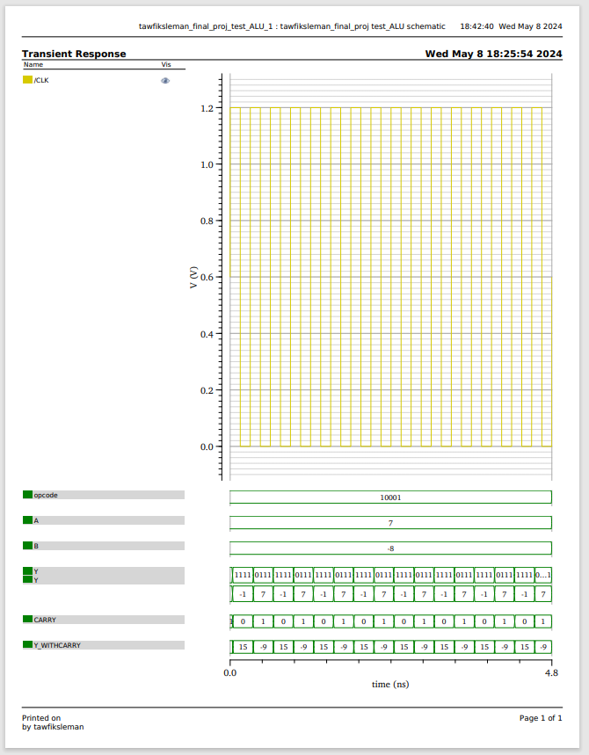

In the graph, we see that when Y=1111 in 2's complement (equivalent to -1 in decimal) and b=1000 in 2's complement (equivalent to -8 in decimal) was inputted into the ALU with opcode 10001, representing the "add with feedback" command. The resulting output is -1(in decimal) with overflow when mean -9 (in decimal) considering carry out, and when Y=0111 in 2's complement (equivalent to 7 in decimal) and b=1000 in 2's complement (equivalent to -8 in decimal) the output is -1 with no overflow.

**Subtract test:**

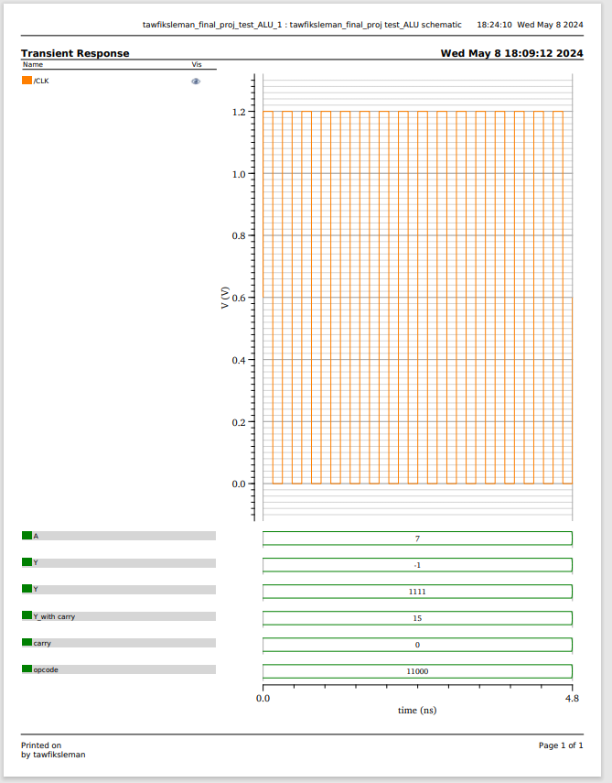

In the graph, we see that A=0111 in 2's complement (equivalent to 7 in decimal) and b=1000 in 2's complement (equivalent to -8 in decimal) was inputted into the ALU with opcode 11000, representing the "subtract" command. The resulting output is 01111 (considering carryout bit), which translates to 15 in decimal. Upon subtracting 7 and -8, we observe that XOR(CarryIN-4bit, Carryout-4bit) =1 indicating of overflow.

**BSR TEST:**

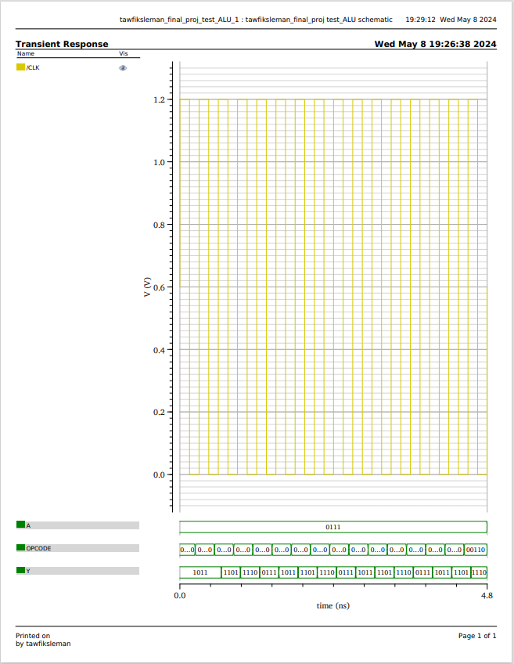 In the graph, we see that A=0111 in 2's complement (equivalent to 7 in decimal was inputted into the ALU with opcodes 00000 which mean 1 right shift, 00001 which mean 2 right shift, 00010 which mean 3 right shift, 00011 which mean 4 right shift, when opcode is 00000 the output is 1011 and for opcode 00001 the output is 1101 and for opcode 00010 the output is 1110 and for 00011 opcode, the output is 0111 which 7 In decimal as we expect.

**XOR TEST:**

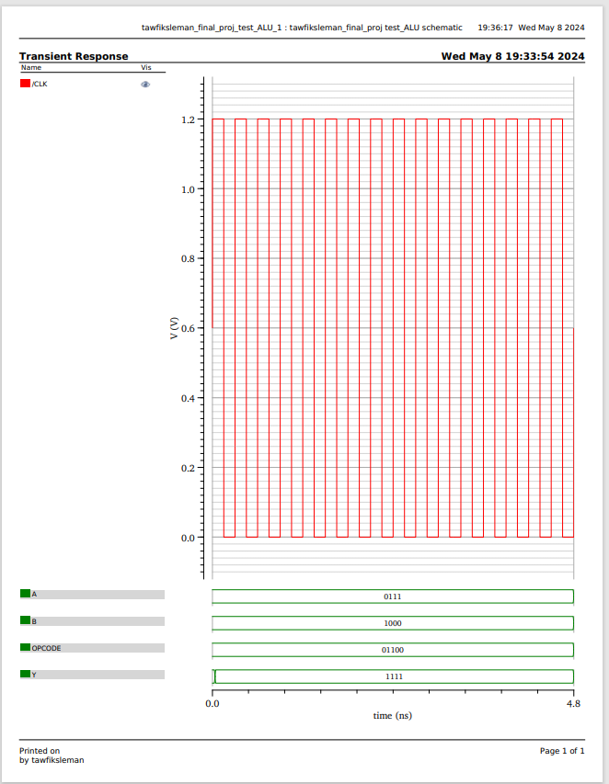In the graph, we see that A=0111 in 2's complement (equivalent to 7 in decimal) and b=1000 in 2's complement (equivalent to -8 in decimal) was inputted into the ALU with opcode 01XX0, representing the "XOR" command. The resulting output is 1111 as we expected a bitwise between A and B